For the stickers (or what I call “badges” in my classes), I use Avery.com and a template (8293, 1.5 inch circle size). If interested, you would make an account and go to Projects and then Create New Project.

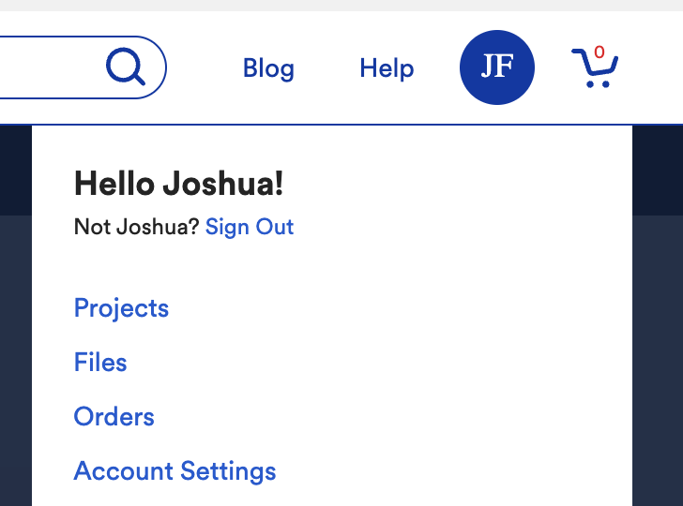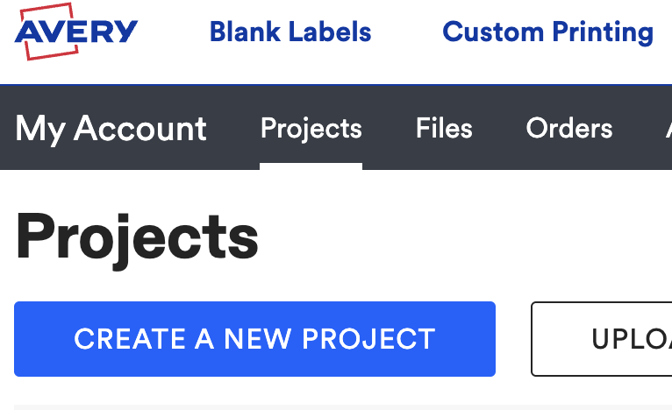

You can select from so many different templates, but I tend to use the blank white one often. I used to buy these exact Avery badges, but found knock offs that are cheaper and larger quantities.
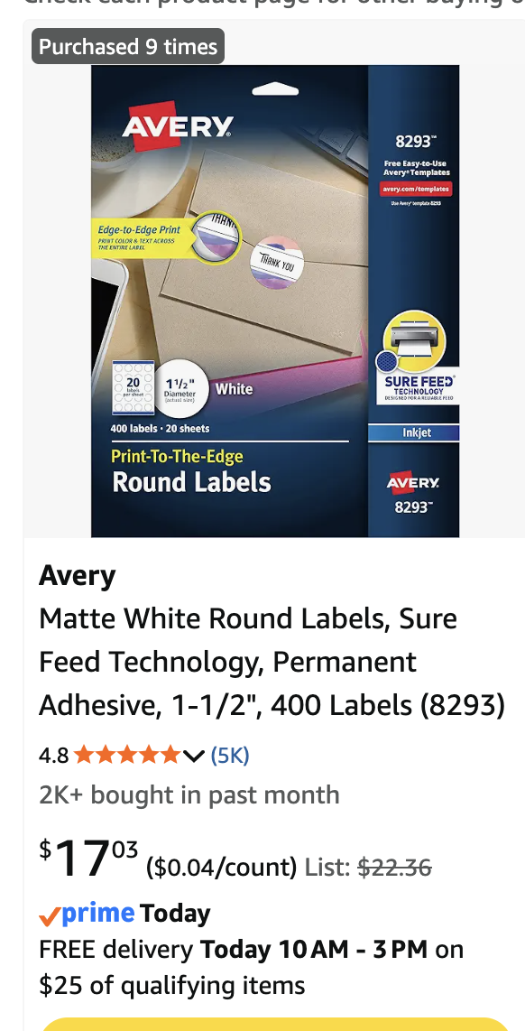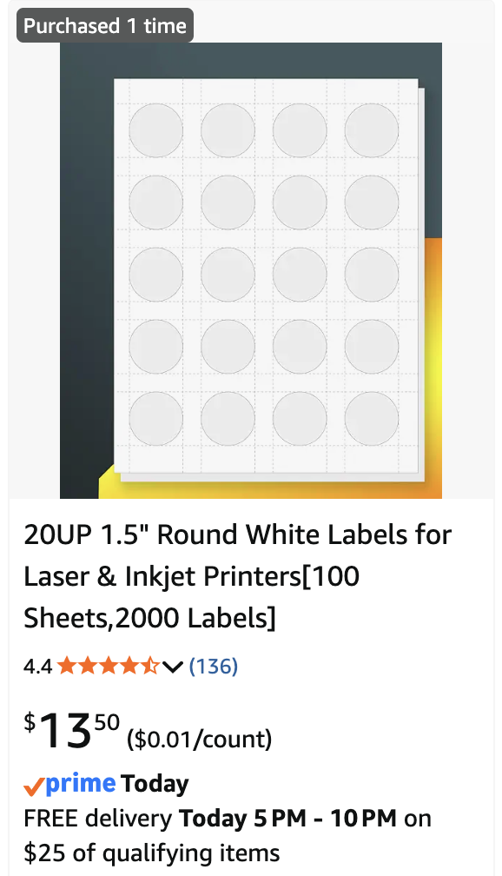
There are also other sizes, varieties, etc. I print them at home on my printer, but make sure that you put the sticker pages upside down in the tray. You can customize whatever you want, and I often start off with the blank white background.

Monday sticker: Life is Complicated
Tuesday sticker: All models are wrong
Wednesday sticker: Let’s be friends
Thursday sticker: Get a life…cycle
Friday sticker: In Tina We Trust
Anytime/Photo Challenge sticker: Above and Beyond

